**CURRICULUM VITAE**

Name : Mr. Dhakane Pravin Rajendra 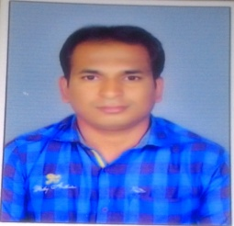

Date of birth : 11 /03/1990

Address for correspondence :7A, Shriram colony , Nayaku Nagar, Bhingar,

Dist. Ahmadnagar , (MH) pin -414 001

Contact Number : +91 9403597116

Email : [dhaknepravin](mailto:pranayogale2014@gmail.com)11@gmail.com

**Educational Qualifications :**

|  |  |  |  |  |
| --- | --- | --- | --- | --- |
| **Sr. No.** | **Examination** | **Board/ University** | **Year of**  **Passing** | **% Marks** |
| 1. | B. Tech.  (Agril. Engg.) | VNMKV, Parbhani | 2017 | 67.60 |
| 2. | HSC | Aurangabad | 2010 | 62.83 |
| 3. | SSC | Aurangabad | 2008 | 71.53 |

**Trainings:**

|  |  |  |  |
| --- | --- | --- | --- |
| **Sr. No.** | **Subject** | **Place** | **Duration** |
| 1. | Operation and Maintenance  of Tractor. | Nort Eastern Region Farm Machinery  Training and Testing Institute, ASSAM | May 2012 |
| 2. | Indian Meteorology Department | Indian Meteorology Department , Agriculture Meteorology Division Pune -5 | May 2013 |
| 3. | Tirth Agro Technology Pvt. Ltd. | Tirth Agro Technology Pvt. Ltd., Rajkot, 360311 | Jan 2017 |

**Extra Curricular Activity** :

Participation in National Service Scheme (NSS)

**Personal Profile**

Full Name Dhakane Pravin Rajendra

Nationality Indian

Marital Status Single

Date of Birth March 11, 1990

Fathre,s Name Rajendra

Mother,s Name Vandana

Language Known English, Hindi, Marathi

Hobbies Reading,Traveling

**Declaration**

I certify that all information given is true and correct to the best of my knowledge anything found incorrect my candidature shall be liable for cancellation.

Date: